ROAD to the REVOLUTION - STUDY GUIDE

Instructions: You will be allowed to use one notecard on the test. The notecard will be provided to you by Mrs. Totin. Use the study guide questions below as a guide to set up your notecard. Make sure to answer each question on the notecard!

1. List three causes of the French and Indian War.
2. List three effects of the French and Indian War.
3. List three British responses to the French and Indian War.
4. What was the Proclamation of 1763?
5. What are four characteristics of the Sugar Act?
6. List four characteristics of the Stamp Act.
7. LIst two characteristics of the Townshend Acts.
8. List two characteristics of the Tea Act.
9. What are four things that the Intolerable Acts did?
10. Explain the events of the Boston Massacre.
11. Evaluate the image below by Paul Revere. What kind of reaction is Paul Revere trying to stir up in colonists. Cite evidence from the image to explain your answer.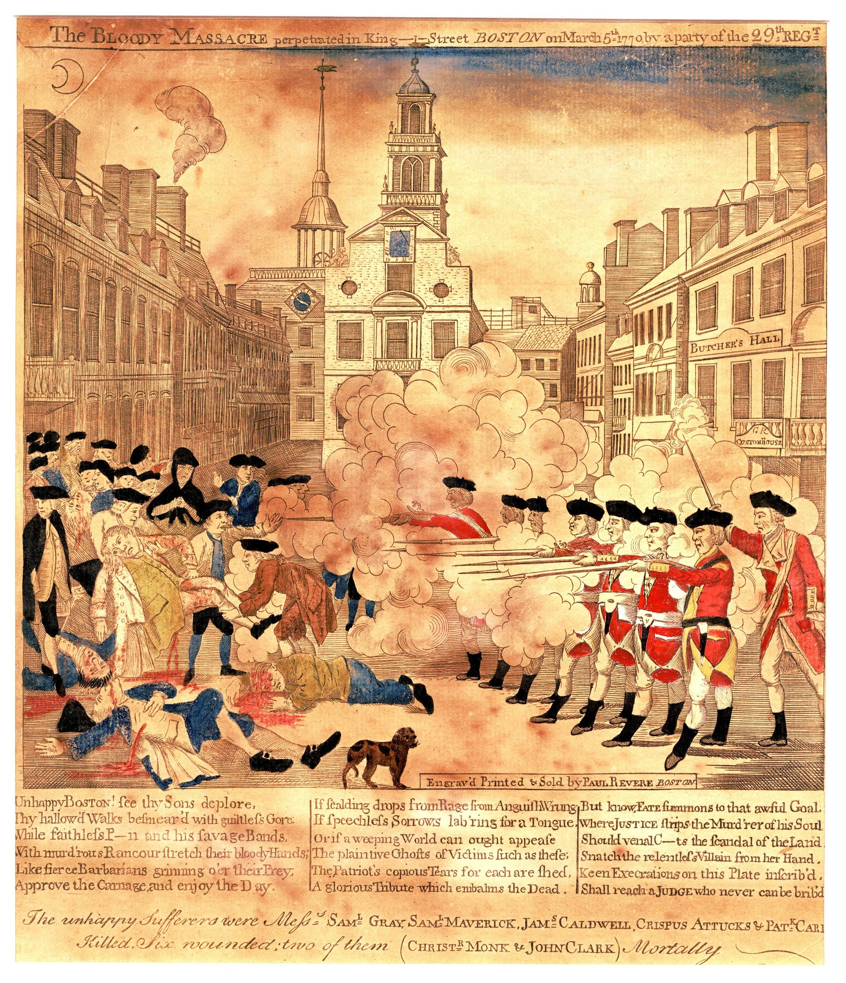
12. Did the British Soldiers act in Self Defense? Or, did they commit murder. Use evidence to explain your answer.
13. Explain the perspectives of both the Patriots and the British on the Boston Tea Party.
14. What was the Battle of Lexington and Concord? Why did ________________ say it was “the shot heard around the world?”